# Smart City Traveller

Submitted in partial fulfillment of the requirements of the degree

**BACHELOR OF ENGINEERING** IN **COMPUTER ENGINEERING**

By

**34-Leah Neville D’souza (192030)**

**37-Rebecca Aurelia D’souza (192034)**

**43-Collin Ferreira (192044)**

**44-Shaun Figueiro (192045)**

Supervisor

**Prof. Ms. Nidhi Gaur, Associate Professor**



**Department of Computer Engineering**

**St Francis Institute of Technology**

**(Engineering College)**

**University of Mumbai**

**(AY 2020-2021)**

# 

# CERTIFICATE

This is to certify that the Second Year Semester IV Mini Project entitled **“Smart City Traveller”** is a bonafide work of **Leah Neville D’souza (A-34), Rebecca Aurelia Dsouza(A-37), Collin Gorden Ferreira(A-43), Shaun Sandeep Figueiro(A-44)** submitted to the University of Mumbai in partial fulfillment of the requirement for the award of the degree of **“Bachelor of Engineering”** in **“Computer Engineering” .**

### (Prof. Ms. Nidhi Gaur)

Supervisor

### (Prof. Dr. Kavita Sonawane) (Prof. Dr. Sincy George)

Head of Department Principal

# Mini Project Approval

This Second Year Semester IV Mini Project entitled “**Smart City Traveller**” by **Leah Neville D’souza (A-34), Rebecca Aurelia Dsouza(A-37), Collin Gorden Ferreira(A-43), Shaun Sandeep Figueiro(A-44)** is approved for the degree of **Bachelor of Engineering** in **Computer Engineering.**

## Examiners

**1………………………………………**

(Internal Examiner Name & Sign)

### 2…………………………………………

(External Examiner name & Sign)

Date: Place

# Contents

### Abstract ii

### Acknowledgments iii

### List of Abbreviations iv

### List of Figures v

### List of Tables vii

### Introduction 1

* 1. Introduction
  2. Motivation
  3. Problem Statement & Objectives
  4. Organization of the Report

### Literature Survey 2

* 1. Survey of Existing System
  2. Limitation Existing system or research gap
  3. Mini Project Contribution

### Proposed System (eg New Approach of Data Summarization ) 4

* 1. Introduction
  2. Architecture/ Framework
  3. Algorithm and Process Design
  4. Details of Hardware & Software
  5. Experiment and Results
  6. Conclusion and Future work.

### References 30

**Abstract:**

Rapid urbanization creates new challenges and issues, and the smart city concept oﬀers opportunities to rise to these challenges, solve urban problems and provide citizens with a better living environment. First, it introduces the origin and main issues facing the smart city concept, and then presents the fundamentals of a smart city by analyzing its deﬁnition and application domains. Secondly, a data-centric view of smart city architectures and key enabling technologies is provided. This project provides a reference to researchers who intend to contribute to smart city research and implementation. The pivotal focus of our web application is to provide a user friendly interface that helps travellers by recommending travel locations based on the user input.

**ii**

**Acknowledgements:**

We extend our sincere and heartfelt gratitude to our esteemed guide Prof. Ms. Nidhi Gaur, for providing us with the right guidance and advice at the crucial junctures and for showing us the right way. We would like to thank our friends and family for the support and encouragement they have given us during the course of time.

**iii**

**List of Abbreviations:**

|  |  |
| --- | --- |
| I. API - | Application Programming Interface |
| II. JS – | JavaScript |
| III. DHTML - | Dynamic HyperText Markup Language |
| IV. UI – | User Interface |
| V. CSS – | Cascading Style Sheets |
| VI. MySQL – | My Structured Query Language |
| VII. XAMPP – | Cross-platform, Apache, MySQL, PHP and Perl |
| VIII. PHP – | Hypertext Preprocessor (earlier called as Personal Home Page) |
| IX. FAQs – | Frequently asked questions |
| X. ICT – | Information Communication Technology |
| XI. IBM – | International Business Machine |

**iv**

**List of Figures:**

|  |  |  |
| --- | --- | --- |
| **Fig. No.** | **Figure Name** | **Page No.** |
| i. fig 3.1 | Proposed Architecture | 5 |
| ii. fig 3.2 | Use Case Diagram | 6 |
| iii. fig 3.3 | Flowchart | 7 |
| iv. fig 3.4 | ER - diagram | 8 |
| v. fig 3.5 | Relational Schema | 9 |
| vi. fig 3.6.a | Home page | 15 |
| vii. fig 3.6.b | Home page | 16 |
| viii. fig 3.6.c | Home page | 16 |
| ix. fig 3.7 | Directions page | 17 |
| x. fig 3.8.a | Sign Up page | 17 |
| xi. fig 3.8.b | Sign Up page | 18 |
| xii. fig 3.9.a | Login page | 18 |
| xiii. fig 3.9.b | Login page | 19 |
| xiv. fig 3.10.a | Profile page | 19 |
| xv. fig 3.10.b | Profile page database | 20 |
| xvi. fig 3.11.a | Create a schedule page | 21 |
| xvii. fig 3.11.b | Create a schedule page | 21 |
| xviii. fig 3.12 | View schedule page | 22 |
| xix. fig 3.13.a | Venues page | 22 |
| xx. fig 3.13.b | Venues page | 23 |
| xxi. fig 3.14 | Location page | 23 |
| xxii. fig 3.15.a | Search reviews page | 24 |
| xxiii. fig 3.15.b | Search reviews page | 24 |
| xxiv. fig 3.15.c | Search reviews page | 25 |
| xxv. fig 3.16 | Get directions page | 25 |

**v**

|  |  |  |
| --- | --- | --- |
| **Fig. No.** | **Figure Name** | **Page No.** |
| xxvi. fig 3.17.a | Write reviews page | 26 |
| xxvii. fig 3.17.b | Write reviews page | 26 |
| xxviii. fig 3.17.c | Write reviews page | 27 |
| xxix. fig 3.17.d | Show reviews page | 27 |
| xxx. fig 3.17.e | View reviews on profile page | 28 |
| xxxi. fig 3.18.a | Feedback page | 28 |
| xxxii. fig 3.18.b | Feedback page | 29 |

**vi**

**List of Tables:**

|  |  |  |
| --- | --- | --- |
| **Table No.** | **Table Name** | **Page No.** |
| 1. Table 1 | Database Table | 9 |
| 1. Table 2 | Detail Table | 10 |
| 1. Table 3 | Feedback Table | 11 |
| 1. Table 4 | Review Table | 12 |
| 1. Table 5 | Signup Table | 13 |
| 1. Table 6 | Trip Table | 14 |

**vii**

**1.** **Introduction:**

**1.1 Introduction**

Travelling is one of the most common ways to spend the holiday. At present, in general tourists and travellers waste a lot of time planning and deciding their trips to achieve maximum satisfaction. In this context, this application aims to identify the main computing needs to support the improvement of tourist point of promotion for the traveller, by the means of an easy-to-use web application proposal. Normally, most travellers like to visit the famous sightseeing spots as well as local charms unique to that place. To achieve this, we propose a system that can automatically show a travel route and plan for the user.

The concept of the smart city has attracted world interest, including governments, companies, universities and institutes. Diﬀerent stakeholders have tried to understand and explain the smart city from their diﬀerent viewpoints. The term ‘smart city’ appeared for the ﬁrst time in the early 1990s, and researchers have emphasized technology, innovation and globalization in the process of urbanization. [1] Smart cities have attracted great attention since 2008, with the launch of IBM’s Smarter Planet project. Since then, the concept of smart cities has continued to grow and evolve.

**1.2 Motivation**

Windows operating system comes with an inbuilt Maps application. But Gen-Z today relies mostly on technology that provides an all in one application. Hence, our online smart city traveller web application allows you to choose the place of your choice and also gives directions to the desired location on the internet. It has many great things to offer as compared to their counterparts. A few of them include accessibility everywhere, the work is available online, no installation process required, easy to use and can be saved on one’s system easily, no cluttered tools, etc.

These features come in handy in all aspects of tourism. Thus, our aim is to build a smart city traveller app that is easily accessible, efficient, simple and easy to use.

**1.3 Problem Statement and Objectives**

**Problem statement:**

The world is moving forward in the field of technology and yet it is slow in the tourism industry. The people still are ignorant about the smart tourism application. Furthermore it is quite difficult in decision making of travelling spots, hotels, exploring places. In a developing country there will be a need of smart tourism that is beneficial to everyone.

And hence our project will include the following features:

* A user friendly interface which will link the user with their nearby places using the FourSquare API

1

* Provide the user with a number of choices for places of each category.
* Create a recommendation list for the traveller travelling to a city based on the choices about their preference and location selected.
* Generate feedback
* Create an account and update profile details along with reviews written by the user.
* Display reviews on various locations
* Provide directions Using Mapbox API

**Objectives:**

The objective of our project systems is to propose an interactive website that helps determine a travel route and a plan for the user. The proposed system helps simplify decision making with respect to the places to visit.

**1.4 Organization of Report**

Our white book report consists of 3 chapters:

* **Chapter 1** gives us a short overview of the project, highlighting the problem statement and the objective behind the same.
* **Chapter 2** highlights the literature survey where we’ve included various websites and research papers. These have helped us in ensuring a smooth efficient experience of our website.
* **Chapter 3** mainly deals with the approach towards our project. It includes everything related to the architectural framework, the various algorithms used while building the website, and the process design. It also includes the hardware and software used while building the website. And lastly, we speak about the future development of the project.

### 

### 2. Literature Survey

**2.1 Survey of Existing System**

**Literature Review**

Today, the Internet plays a very crucial role in every business domain as well as in real life. Travel and tourism industry is no such exception since a huge part of its success relies on these applications. Quite simply, if mobile technology’s impact on general society over the last decade has been extensive.[2] Current methods for planning a trip involve estimation of time for visiting places, selecting places of interest and evaluating convenient routes, all within a stipulated time frame.

The current system projects take into consideration a time constraint defined by the user.Current systems consider GPS data in real time and calculate the distance

2

based on the latitude and longitude of the places, from the user’s current location. A

real time database is required by systems to store the current location of the user, also it can be used for storing and analysing the relational database which is an important aspect. One of the parameters for selecting locations depends on its shortest distance from the user’s current location.

ICT is helping the tourism industry with technical systems that support the relationship between business and customers mainly via the Internet. For example, new technology infrastructures allow tourism stakeholders to create technology- based services, and to have the mechanisms to access and create data that can provide insights on how visitors consume a destination.[3] For this reason, the concept of Smart Tourism Destinations becomes an interesting topic

**2.2 Limitations of Existing system / Research Gap**

### 

### Limited Accuracy

Occasionally, ambiguities and flaws in location data may produce a route that doesn't take you to the destination you expect.[4] Most of the websites and applications do not have up-to-the-minute information on unusual conditions, such as roads damaged by weather, blocked by street fairs or altered by recent construction work. Such projects do not work well in places which aren’t “Map literate”.

### Missing Information

Depending on the country and location you are interested in, you may find that entire buildings are blurred out in Street View.[5] This is done on request because of privacy concerns, but this also severely limits the usefulness of the feature. Similarly, in the satellite view, certain areas may be displayed using older imagery or may be blurred out altogether.

### Invasion of Privacy

Some websites and mobile applications track all your searches and this information can be used against you. Your Location information is with these websites and although rare, can be potentially misused.[6] Third Party applications may also use the users location information and searches to filter advertisements sent to the user.

### Narrow Search Window

Certain websites only allow the user to search for certain types of venues and places, this narrows down the usability of the website. Also most of the map based applications and websites do not allow the user to set a time constraint, further limiting their usage. Also, majority of these websites don’t have the feature of automatically suggesting a list of relevant venues according to their user[7]

3

**2.3 Mini Project Contribution**

* This project will prove that it opens the ground on how to transpose smartness to tourism and destination levels.Our system will also collect feedback from different tourists and will be helpful for users planning a trip.
* These mentioned features will save enormous time for the user and will be helpful in organizing a destination place. As a result we witness the dawn of an age of smart tourism. The future scope of this application will be responsive and more dynamic with machine learning concepts.
* A website like Smart City Traveller will lead to quicker decision making by the user. A simple user- friendly, jargon free interface will ensure that users of all types can easily interact with the application.
* This project will help in understanding the present scenario of growing popularity of smart cities in India and execute sustainable plans for the development of smart cities, which will ultimately lead the way to smart tourism destinations.

**3. Proposed System**

**3.1 Introduction**

In the proposed system, the system automatically searches for places of interest around the location. So, the traveller will not miss out on any attractions which he is unaware of. The interests and preferences of the user are also considered and the places are chosen accordingly.

We make a list of sightseeing information according to sightseeing categories. In the result, we display both guidance routes on the map and guidance routes by text. The application displays a menu with main categories of attraction available in the city, by clicking on one of the categories all the related information is displayed.

4

**3.2 Architecture/Framework**

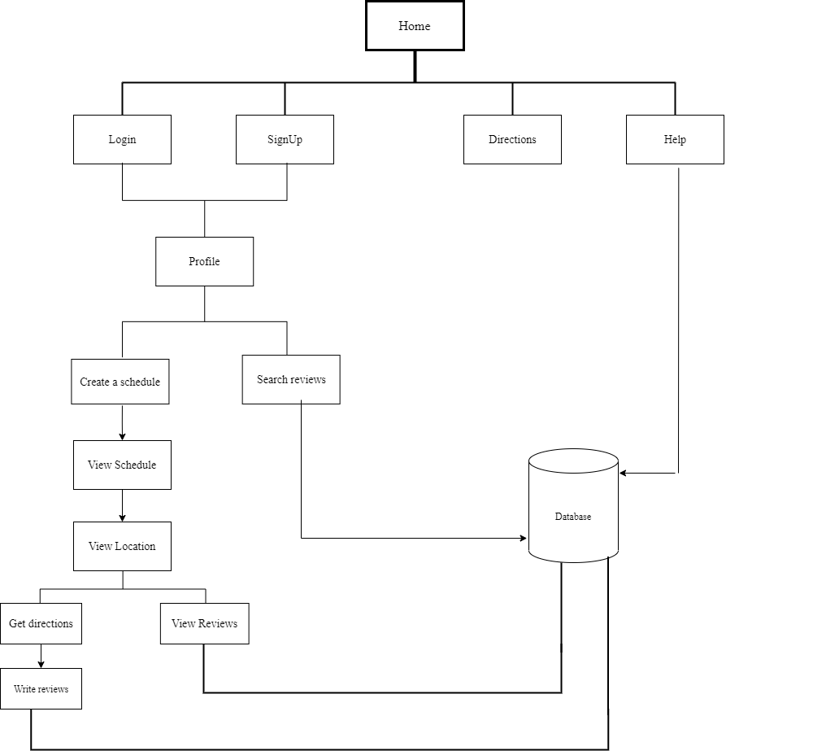

**fig 3.1 Proposed Architecture**

The smart city web application consists of various pages designed using DHTML, CSS and JavaScript. The home page is the opening page to the web-application. The flow of activities that occurs in Smart City Traveller website is portrayed in fig 3.1

**3.3 Algorithm and Process Design**

.

**ALGORITHM:**

The smart city project uses the Foursquare API which works on the Kmeans algorithm.

**K - means Clustering Algorithm:**

K-means clustering algorithm is an iterative algorithm that tries to partition the dataset into *K*pre-defined distinct non-overlapping subgroups (clusters) where each data point belongs to only one group. [8] It tries to make the intra-cluster data points as similar as possible

5

while also keeping the clusters as different (far) as possible. It assigns data points to a cluster such that the sum of the squared distance between the data points and the cluster’s centroid (arithmetic mean of all the data points that belong to that cluster) is at the minimum. The less variation we have within clusters, the more homogeneous (similar) the data points are within the same cluster.

**The way Kmeans algorithm works is as follows:**

· Specify number of clusters *K*.

· Initialize centroids by first shuffling the dataset and then randomly selecting *K* data points for the centroids without replacement.

· Keep iterating until there is no change to the centroids. i.e assignment of data points to clusters isn’t changing.

· Compute the sum of the squared distance between data points and all centroids.

·Assign each data point to the closest cluster (centroid).

·Compute the centroids for the clusters by taking the average of the all data points that belong to each cluster.

**USE CASE DIAGRAM:**

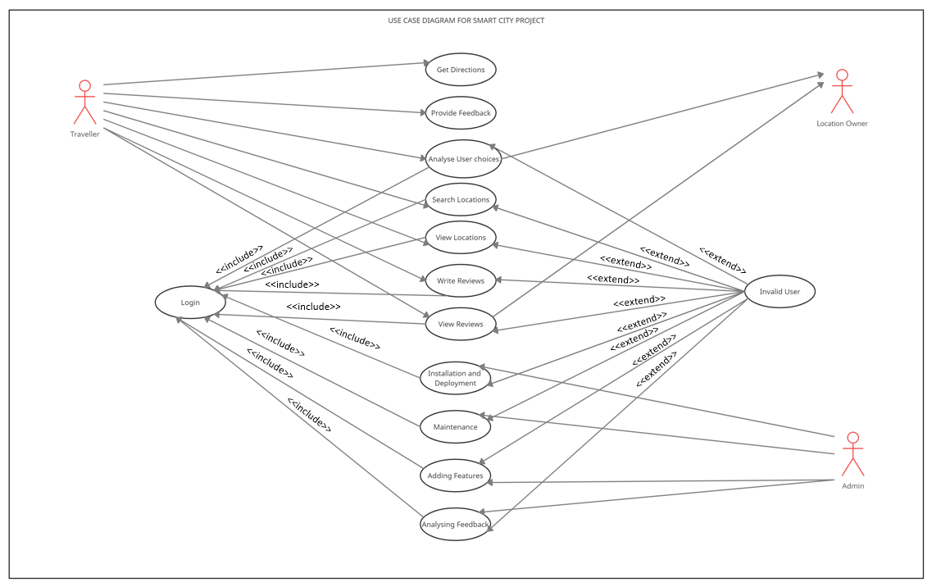

**fig 3.2 Use Case Diagram**

6

**FLOWCHART:**

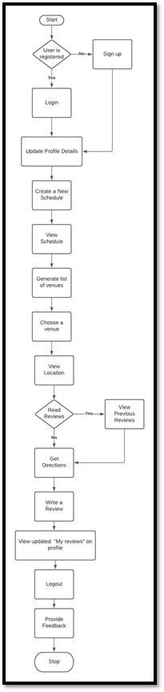

**fig 3.3 Flowchart**

7

**PROCESS:**

1. The user if not registered has to firstly sign up into our website. A user with an already registered email id is not allowed to register. On successful registration, the user is directed to the profile page. A previously registered user can directly login to view the profile page. On successful login to the profile page, the user can update their personal details.

2. Further on, selecting the create a schedule option allows the user to enter their choice of location, the date, start and end time as well as the desired choice such as restaurant, garden, malls, library, etc. On entering the details, the user is shown a schedule of the submitted details and a list of venues to select from are displayed. The Foursquare API is used for this purpose.

3.The Foursquare Places API provides location based experiences with diverse information about venues, users, photos, and check-ins. The API supports real time access to places, Snap-to-Place that assigns users to specific locations, and Geo-tag. Additionally, Foursquare allows developers to build audience segments for analysis and measurement. JSON is the preferred response format.

4.Upon selection of venue, the location of the place is shown on an embedded map and the user gets a choice to either view reviews for the venue or directly get directions for the same.

5. After completion of the trip, the user can then enter a new review about their experience which is then displayed on the user’s profile page as well in the search reviews section.

6. The user can then logout of their profile and fill the feedback form in the help section to help the admin better the working of the website.

**ER – Diagram For Smart City Traveller App:**

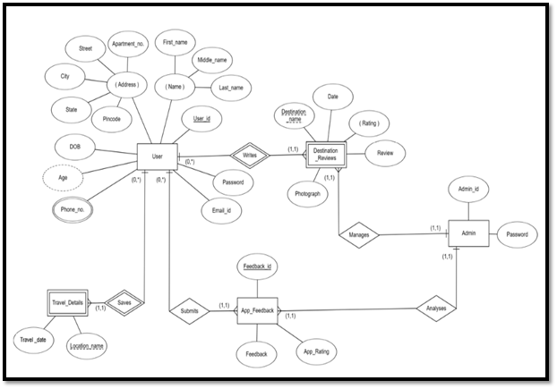

**fig 3.4 ER - Diagram**

8

**RELATIONAL SCHEMA FOR PROJECT:**

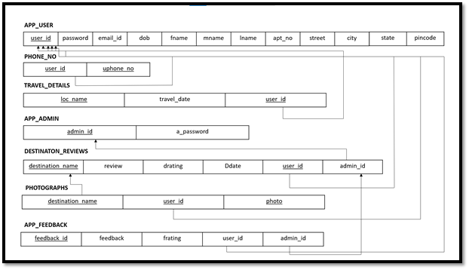

**fig 3.5 Relational Schema**

**Table Design**

* Main Database for the project – Database name: smart city

|  |
| --- |
| DATABASE: “smart city” Tables |
| 1. detail |
| 2. feedback |
| 3. review |
| 4. signup |
| 5. trips |

**Table 1: Database Table**

9

* “detail” table from database: details are stored in this table about user’s choices for the trip

|  |  |  |
| --- | --- | --- |
| # | NAME | TYPE |
| 1 | id | int(10) NOT NULL |
| 2 | email | varchar(30) NOT NULL, |
| 3 | tdate | varchar(15) NOT NULL |
| 4 | city | varchar(20) NOT NULL |
| 5 | stime | varchar(10) NOT NULL |
| 6 | etime | varchar(10) NOT NULL |
| 7 | choice | varchar(30) NOT NULL |

**Table 2: Detail Table**

10

* “feedback” table from database: The feedback reviews are stored in the table below

|  |  |  |
| --- | --- | --- |
| # | NAME | TYPE |
| 1 | id | int(10) NOT NULL |
| 2 | feedback | longtext NOT NULL |
| 3 | rating | enum('1','2','3','4','5') NOT NULL |

**Table 3: Feedback Table**

11

* “review” table from database: The destination reviews are stored in the table below

|  |  |  |
| --- | --- | --- |
| # | NAME | TYPE |
| 1 | id | int(10) NOT NULL |
| 2 | email | varchar(30) NOT NULL |
| 3 | place | varchar(30) NOT NULL |
| 4 | review | longtext NOT NULL |
| 5 | image | longblob NOT NULL |
| 6 | rating | enum('1','2','3','4','5') NOT NULL |

**Table 4: Review Table**

12

* “signup” table from database: The user details are stored in the table below

|  |  |  |
| --- | --- | --- |
| # | NAME | TYPE |
| 1 | id | int(10) NOT NULL |
| 2 | username | varchar(30) NOT NULL |
| 3 | email | varchar(30) NOT NULL |
| 4 | pass | varchar(15) NOT NULL |
| 5 | re_pass | varchar(15) NOT NULL |
| 6 | fname | varchar(20) NOT NULL |
| 7 | mname | varchar(20) NOT NULL |
| 8 | lname | varchar(20) NOT NULL |
| 9 | dob | varchar(20) NOT NULL |
| 10 | phone | varchar(20) NOT NULL |
| 11 | addr | longtext NOT NULL |

**Table 5: SignUp Table**

13

* “trip” table from database: details are stored in this table about user’s trips

|  |  |  |
| --- | --- | --- |
| # | NAME | TYPE |
| 1 | id | int(10) NOT NULL |
| 2 | email | varchar(30) NOT NULL, |
| 3 | venue | varchar(30) NOT NULL |
| 4 | rating | varchar(30) NOT NULL |
| 5 | date | varchar(15) NOT NULL |
| 6 | city | varchar(20) NOT NULL |

**Table 6: Trip Table**

**3.4 Details of Hardware and Software**

This section describes the software and hardware requirements of the system

## · Software Requirement:

## · Recommended Operating Systems

· **Windows:** 7 or newer (Preferably Windows 10 64-bit)

· Operating system Database MySQL - MySQL is used as a database as it is easy to maintain and retrieve records by simple queries which are in English language which are easy to understand and easy to write.

· Development tools and Programming language - HTML is used to write the outline of

14

the page, CSS and Bootstrap are used for styling, JavaScript is used for the working of the editor functions and XAMPP server is used for PHP (server-side scripting) connection to database.

· **Hardware requirements:**

* Processor: Minimum 1 GHz; Recommended 2GHz or more
* Ethernet connection (LAN) OR a wireless adapter (Wi-Fi)
* Hard Drive: Minimum 32 GB; Recommended 64 GB or more
* Memory (RAM): Minimum 1 GB; Recommended 4 GB or above

**3.5 Experiment and Result**

Our project mainly comprises of a website with a Home page that provides options to access various parts of our website, the Login page enables user to login to their profile, Signup page registration is a requirement to proceed with our website, Profile page displays the user profile and options for user to start with a new trip, Schedule page helps user create a new schedule for the trip, Venues page displays a list of venues generate by the Foursquare API which is parsed from the JSON string, Locations page shows the exact location of the venue selected by the user, Search Reviews page allows the user to check previously entered reviews by other users for locations visited, Get Directions page enables user to obtain directions from the source destination to the desired venue location, with the help of the Write Review page users can describe their experience by entering a review for their trip, a Help page with FAQs for help with the relative working of the website too is provided along with a feedback area. The Admins of the website can keep tabs on the user input and maintenance of the website by ensuring a check on the database tables created on PHPMyadmin using the XAMPP server.

**HOME PAGE:**

The home page is a gateway to all the other pages of our website. The home page also displays the main purpose and aim of our website.

15

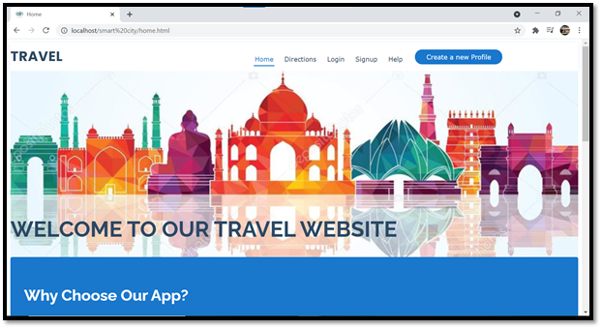

**fig 3.6.a Home Page**

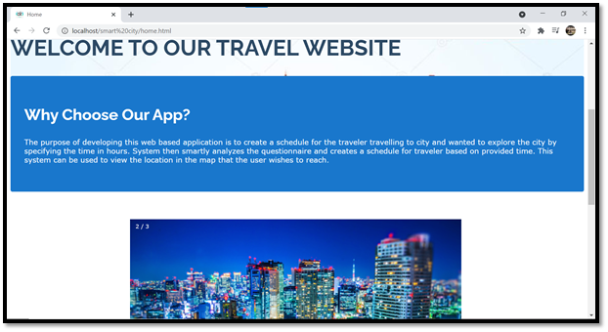

**fig 3.6.b Home Page**

16

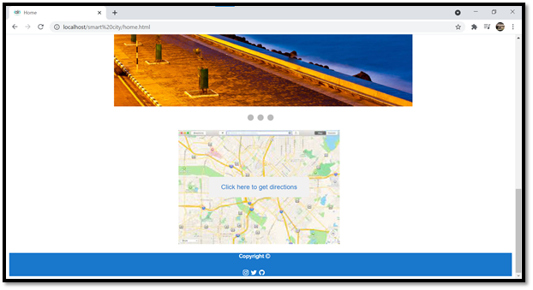

**fig 3.6.c Home Page**

**DIRECTIONS PAGE:**

The directions page offers any user to get directions to a particular location. This page does not require login for accessing the map.

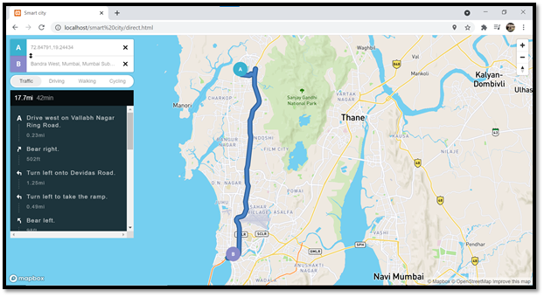

**fig 3.7 Directions Page**

**SIGN UP PAGE:**

Any new user wanting to access the website’s features to create a schedule and view venues needs to first register. A user once registered is not permitted to sign up with the same email

17

id again.

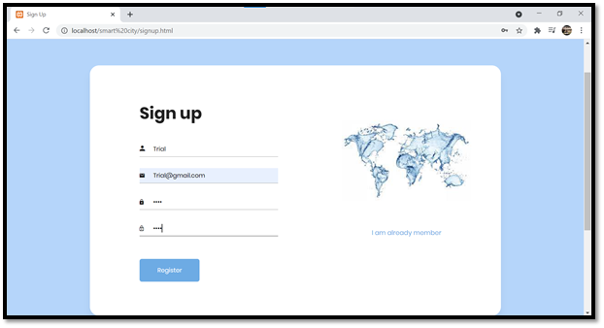

**fig 3.8.a SignUp Page**

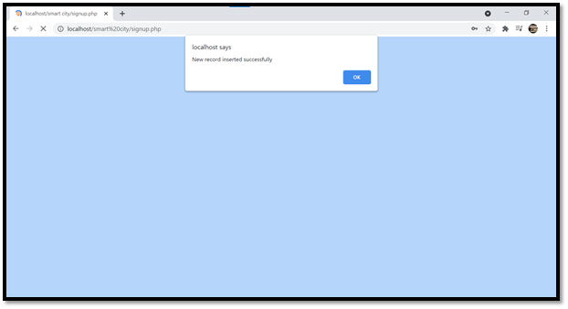

**fig3.8.b SignUp Page**

**LOGIN PAGE:**

An already registered can directly login to their profiles.

18

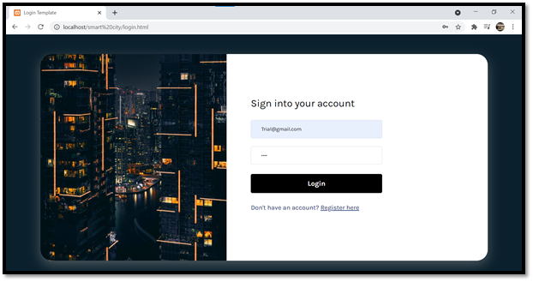

**fig 3.9.a Login Page**

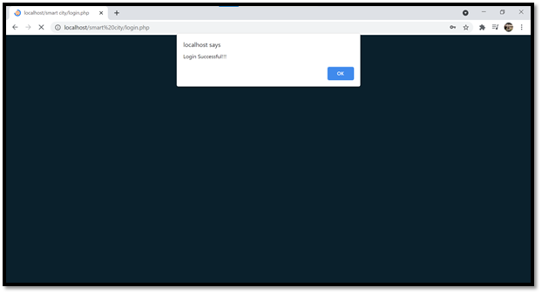

**fig 3.9.b Login Page**

**PROFILE PAGE:**

For any new user the profile page will appear as shown in the figure below.

19

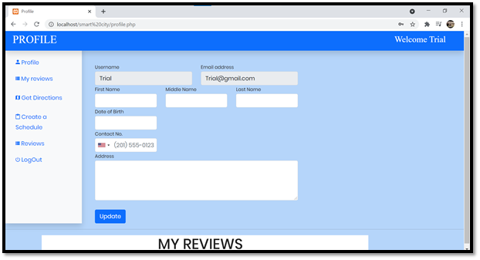

**fig 3.10.a Profile Page**

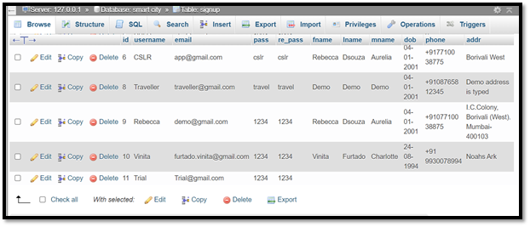

**fig 3.10.b Profile page database**

The user can then update their personal details as shown which is immediately reflected in our database. Except the username and email, the user can update the other details as and when needed.

20

**CREATE A SCHEDULE PAGE:**

The user can start with the process of creating a new schedule for their trip by entering the required details such as date, city, start and end time as well as their choice of place to visit.

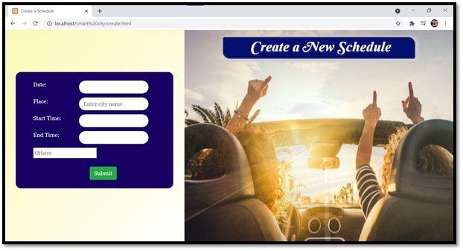

**fig 3.11.a Create a schedule page**

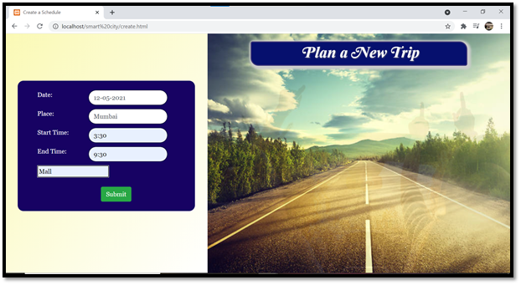

**fig 3.11.b Create a schedule page**

**VIEW SCHEDULE PAGE:**

The user can view a tabular form of their submitted choices on this page. If the user is not satisfied with their choice or finds the need to change it, they can create a new schedule immediately.

21

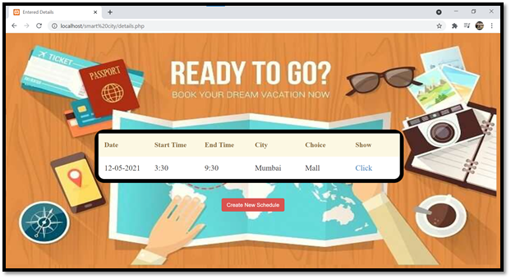

**fig 3.12 View Schedule Page**

**VENUES PAGE:**

The venues page displays a list of the locations generated by the Foursquare API using the Kmeans clustering algorithm. The user can view the ratings for the location too along with its name and can select any venue to move ahead with the process.

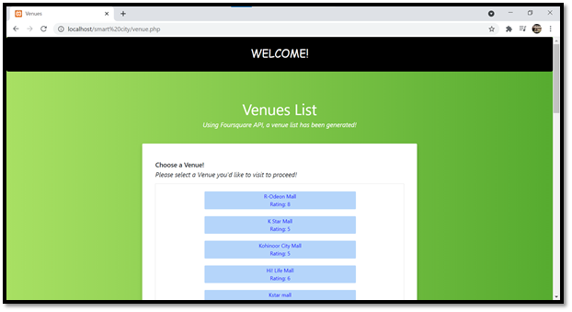

**fig 3.13.a Venues Page**

22

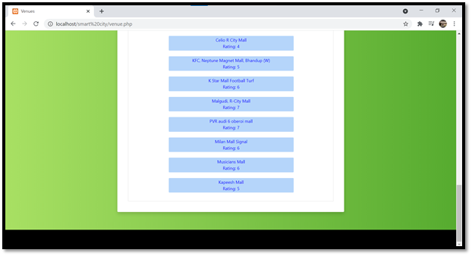

**fig 3.13.b Venues Page**

**LOCATION PAGE:**

After selecting the desired venue, the user is then redirected to a location page where the exact location of the selected venue is displayed. This is achieved with the use of Mapbox API. From here on, the user can either read the previously submitted reviews for the venue or directly proceed with the directions page.

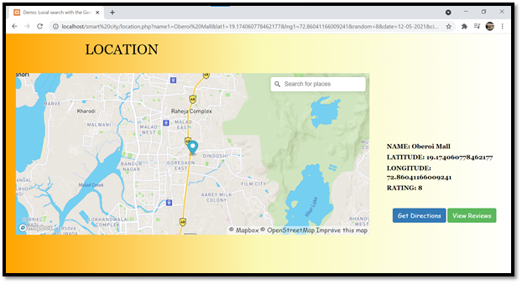

**fig 3.14 Locations page**

23

**SEARCH REVIEWS PAGE:**

This page enables searching for previously entered reviews from other users. The user can enter their location name and read the reviews for the same.

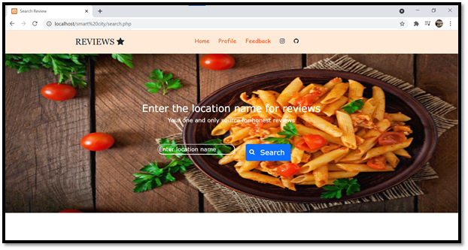

**fig 3.15.a Search Reviews Page**

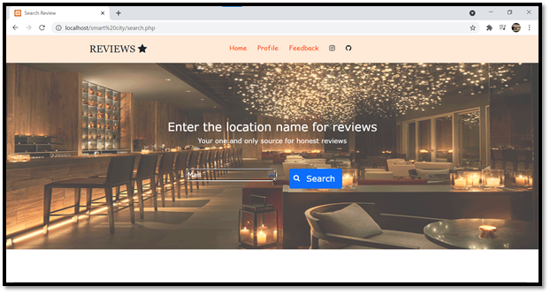

**fig 3.15.b Search Reviews Page**

24

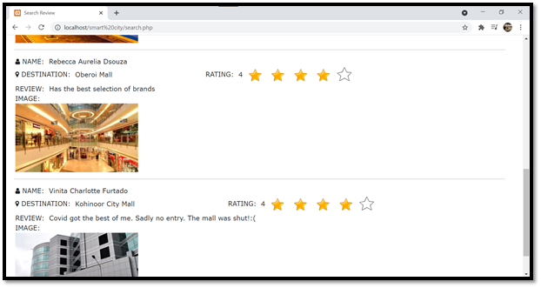

**fig 3.15.c Search Reviews Page**

**DIRECTIONS PAGE:**

This directions page is designed slightly different from the one led by the home page. The following page is redirected to write a review page which is permitted only for registered users.

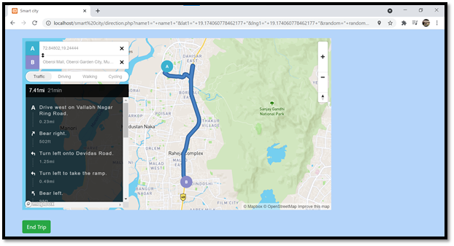

**fig 3.16 Get Directions Page**

**WRITE A REVIEW PAGE:**

After completing the trip successfully, the user can then write a review for the trip. The submitted review is then seen on the user’s profile as well as on the search review page.

25

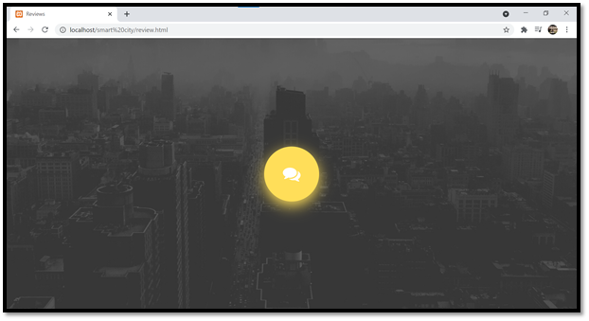

**fig 3.17.a Write Reviews Page**

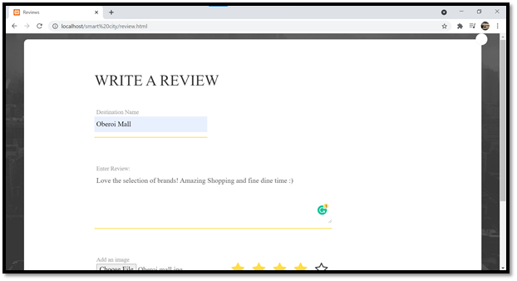

**fig 3.17.b Write Reviews Page**

26

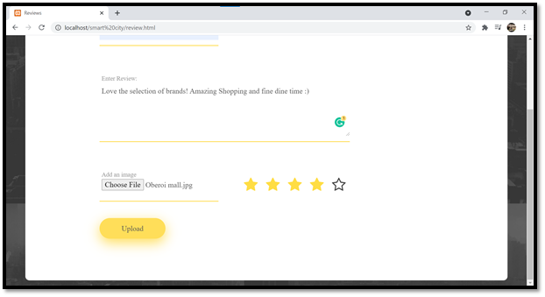

**fig 3.17.c Write Reviews page**

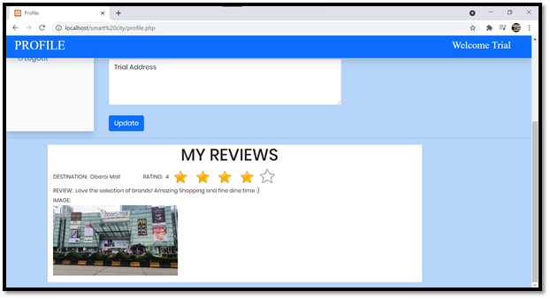

**fig 3.17.d Show Reviews on Profile Page**

27

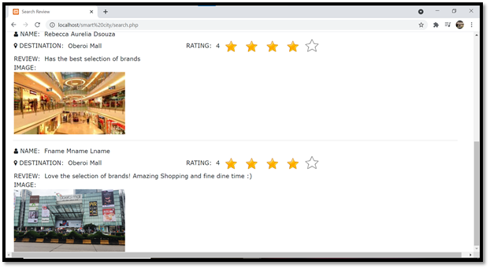

**fig 3.17.e Show reviews on search reviews page**

**HELP PAGE:**

After logout from the profile, FAQs and a feedback section is displayed on the help page. This page is beneficent for not only the user but also the admins as it helps in overall development of the website.

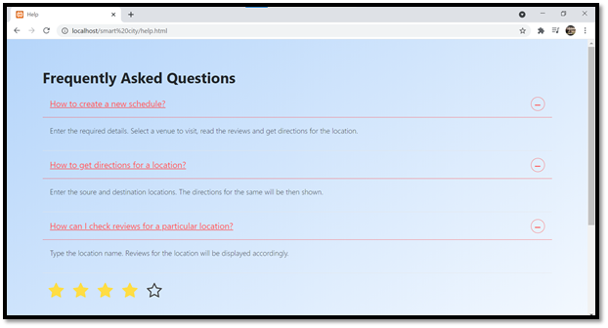

**fig 3.18a: Help Page**

28

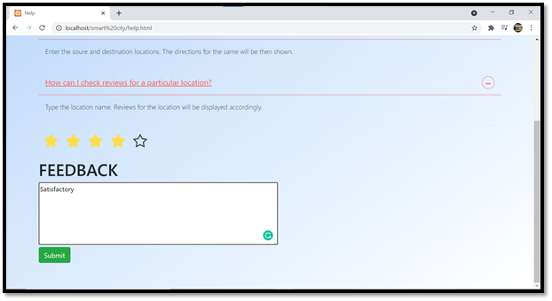

**fig 3.18b: Help Page**

In order to test and check the final working of the website prototype, we also asked a few of our friends and family and got back positive results in the process. All in all, the goals for not only making a full-fledged Travel website was accomplished but also the idea of creating a responsive and user-friendly environment was achieved.

**3.6 Conclusion and Future Work**

This project has presented an initiative to support the transition of a traditional tourism destination into a smart decision. Since travelling is one of the important aspects today, it is very necessary that proper planning be done beforehand in terms of time management. The aforementioned features of our project will save enormous time of the user and will be helpful in organizing a destination place. The project still has the potential for development and future scope. Some of the future scopes for this smart city web-application are:

1. The Internet of Behaviours is an up and coming technology seen recently, that analyses user’s choices from a psychological perspective and presents a list of recommendations based on the user’s choices. The IoB can be incorporated in our project as it will help generate a list of choices based on the user’s previously selected list.
2. With social media on the rise, the future scope of our project can be enabling viewing of other user profiles, creating a followers list for each user as well enabling discussions between the users.
3. Transformation of website into an efficient and functional android application using the flutter framework.

29

**References:**

[1] SMART CITY TRAVELLER", International Journal of Emerging Technologies and Innovative Research (www.jetir.org), ISSN:2349-5162, Vol.6, Issue 5, page no.89-93, May - 2019, www.jetir.org/papers/JETIRCQ06016.pd

[2] Jasrotia, Aruditya & Gangotia, Dr**.** (2018). SMART CITIES TO SMART TOURISM DESTINATIONS: A REVIEW PAPER (ISSN 2249-7307). 1. 47-56.

[3] Cacho, Andréa & Mendes-Filho, Luiz & Alves, Daniela & Moura, Brunna & Cacho, Nélio & Lopes, Frederico & Alves, Cristiano. (2016). Mobile tourist guide supporting a smart city initiative: a Brazilian case study. International Journal of Tourism Cities. 2. 164-183. 10.1108/IJTC-12-2015-0030.

[4] Vijay Jumb, Gauri Gupta, Elton Aloysius, Sahil Kamat, Nachiket Wakankar Assistant Professor, Students Department of Computer Engineering, Xavier Institute of Engineering, INTERNATIONAL JOURNAL OF INFORMATION AND COMPUTING SCIENCE, ISSN NO: 0972-1347

[5] Chin-Jung Huang, Ying-Hong Lin,The Approximate Shortest Distance Route Intelligent System forTravelling for Taiwan Innovative Computing Information and Control, 2006

[6] Ivaldir de Farias Junior, Nelson Leitão Júnior and Marcelo M. Teixeira, “Urbis: A Touristic Virtual Guide”

[7] Harrison, C., Eckman, B., Hamilton, R., Hartswick, P., Kalagnanam, J., Paraszczak, J., &

Williams, P. (2010). Foundations for Smarter Cities. IBM Journal of Research and Development, 54(4).

[8] J. Cui , X. Wang, “Research On Google Map Algorithm and Implementation “, Journal Of Information and Computational Science 5(3):1191-1200, May 2008

30